**Python with Django Internship Report**

**Personal Details**

Name : Parth Rupeshkumar Shah

College Name : Silver Oak College of Engineering and

Technology

Degree : BE

Semester : 7

Github URL : https://github.com/ParthShah25/Akashsir.git

**Company Details**

Company Name : Akash Technolabs

External Guide : Akash Padhiyar

Training Duration : 26-05-2021 to 21-06-2021

**Index**

|  |  |  |
| --- | --- | --- |
| **Index** | **Task Detail** | **Page Name** |
| 1 | Basic Registration page using HTML, CSS. | 3 |
| 2 | Python Variables and Datatypes. | 4 |
| 3 | Python Conditional statement, Loops, Break, Continue, Range and Pass. | 7 |
| 4 | Python OOP’s Concepts. | 10 |
| 5 | Making simple pages using Django (Home, About, Contact). | 13 |
| 6 | Career Guidance website using Django. | 17 |

1. Task – 1: Basic Registration page using HTML, CSS.

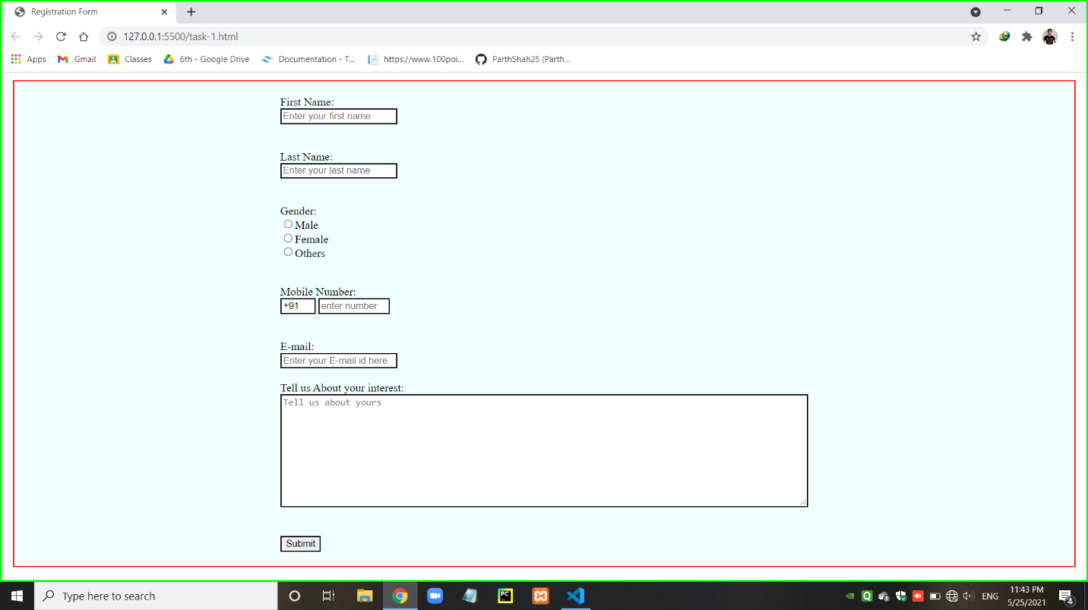

1. Task -2: Python Variables and Datatypes.

* Variable and how to know that variable’s type.

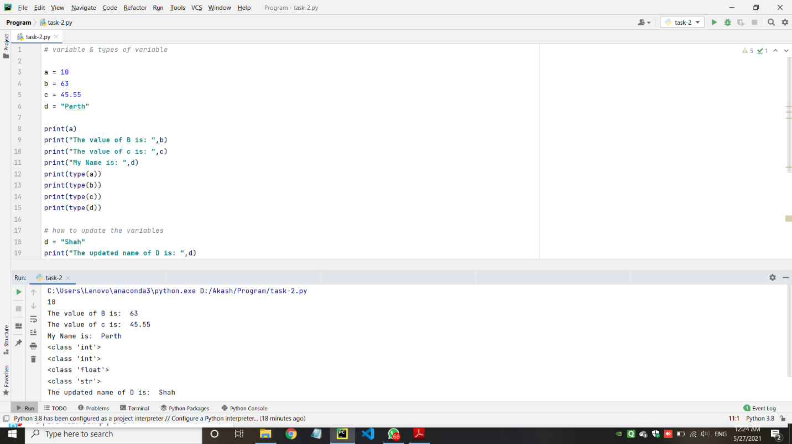

* Data Types in python : Number Datatypes, String Datatypes, List Datatypes, Tuple Datatypes, Dictionary Datatypes. Some Ex:
  + - String Datatypes

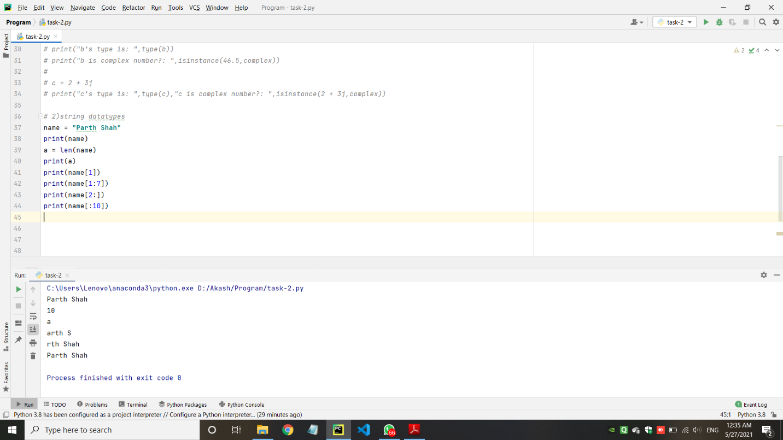

* + - List Datatypes

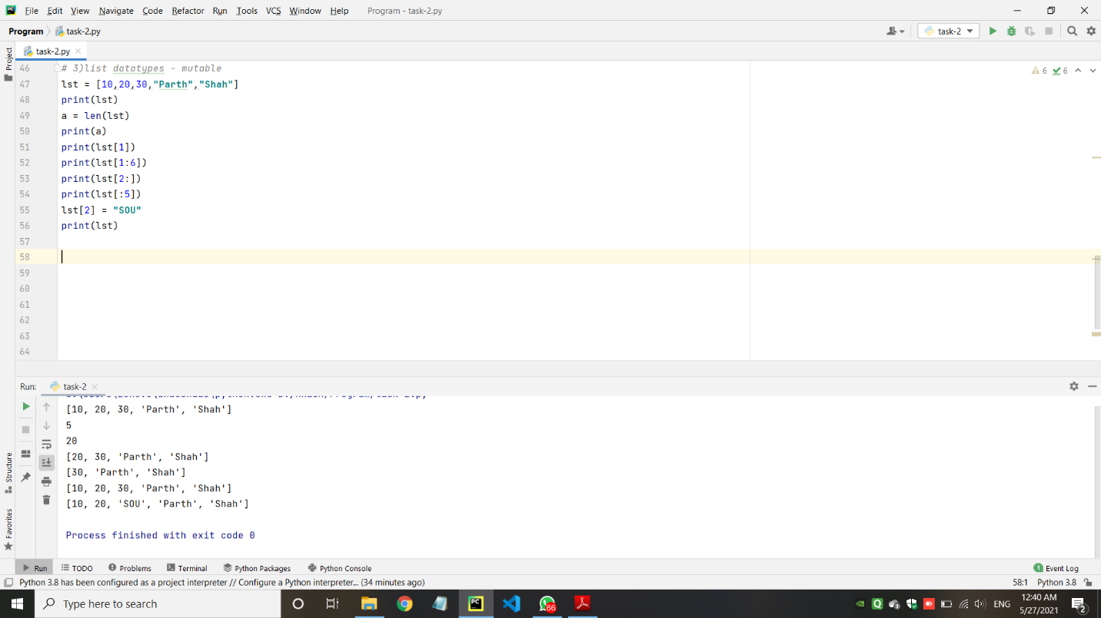

* Tuple Datatypes

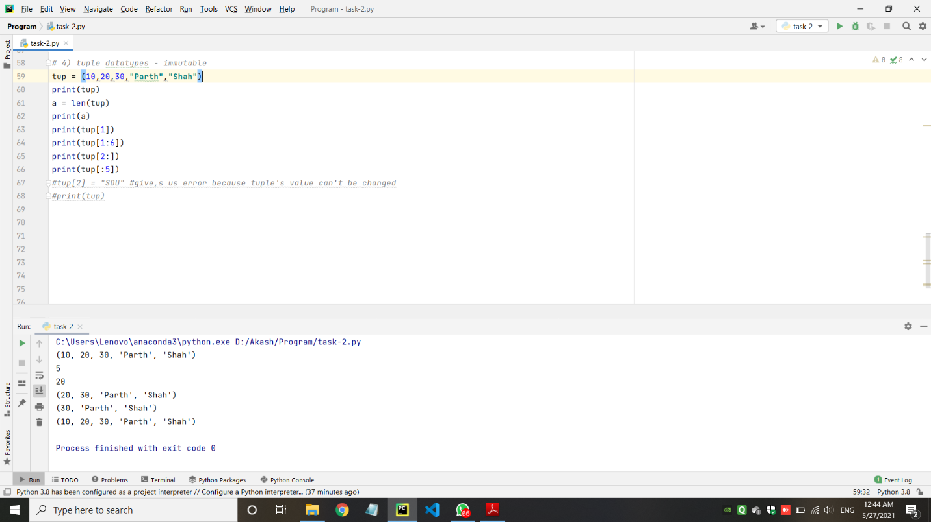

1. Task – 3: Python Conditional statement, Loops, Break, Continue, Range and Pass.

* Take a number and find factorial of that number.

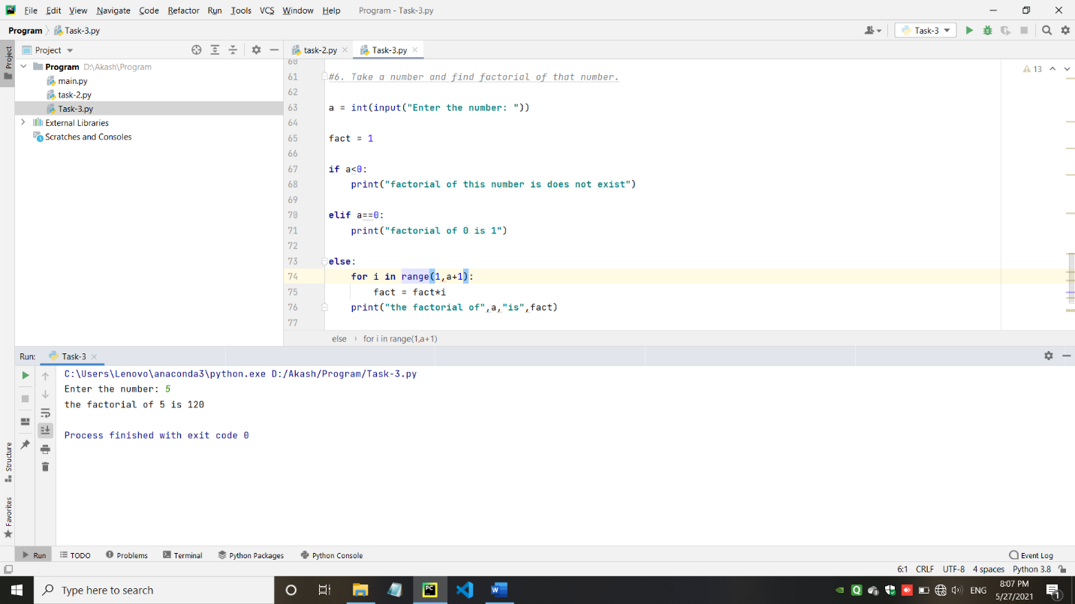

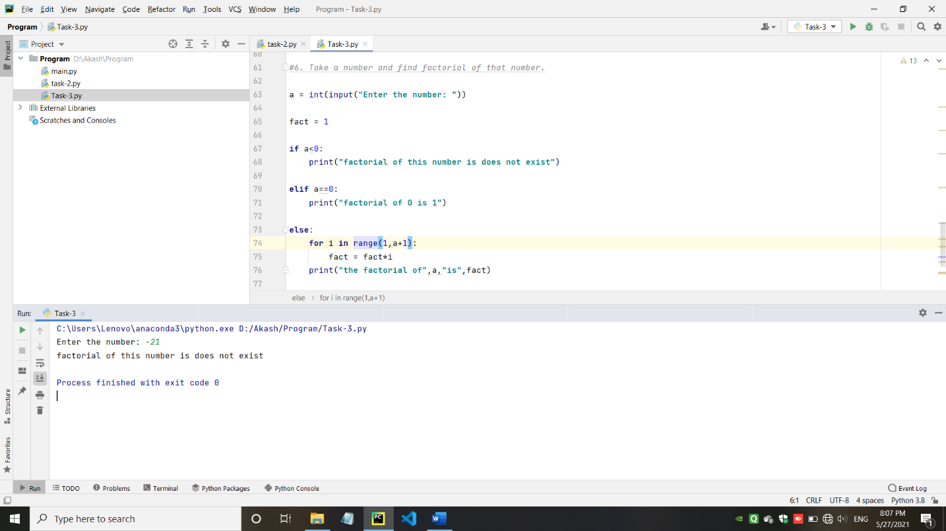

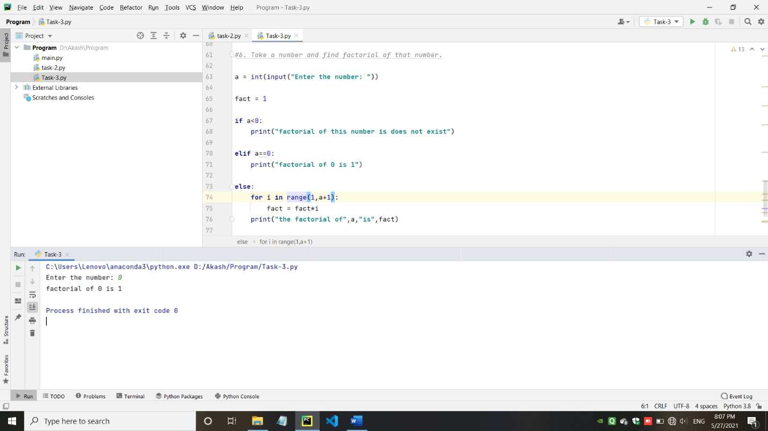

* Write a program to swap 2 numbers using third variable.

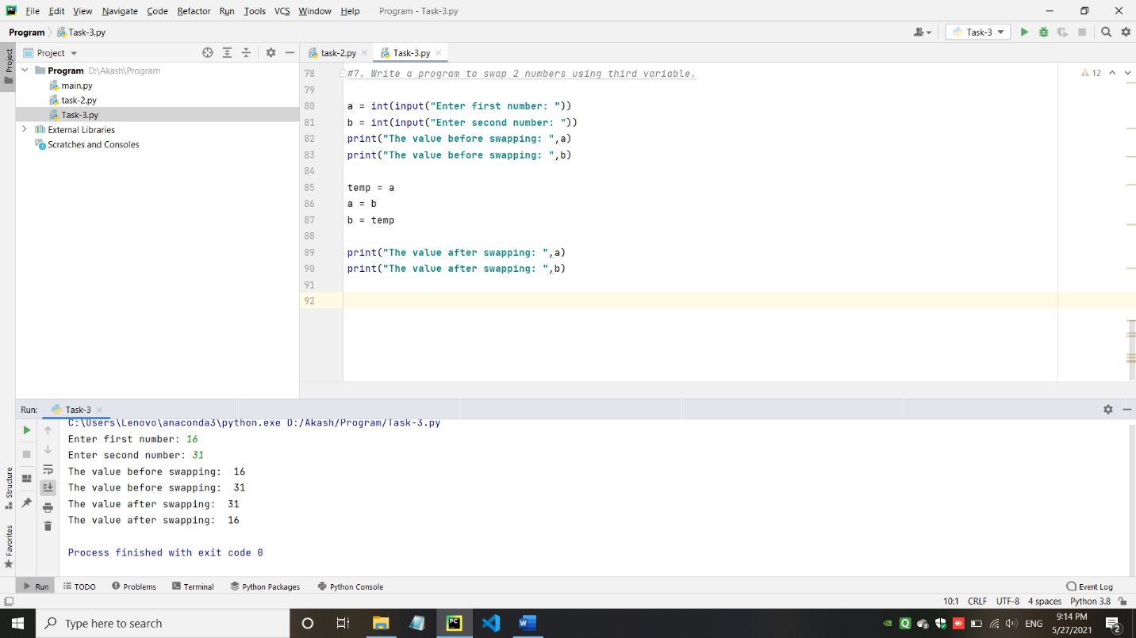

* Write a program to swap 2 numbers without taking third variable.

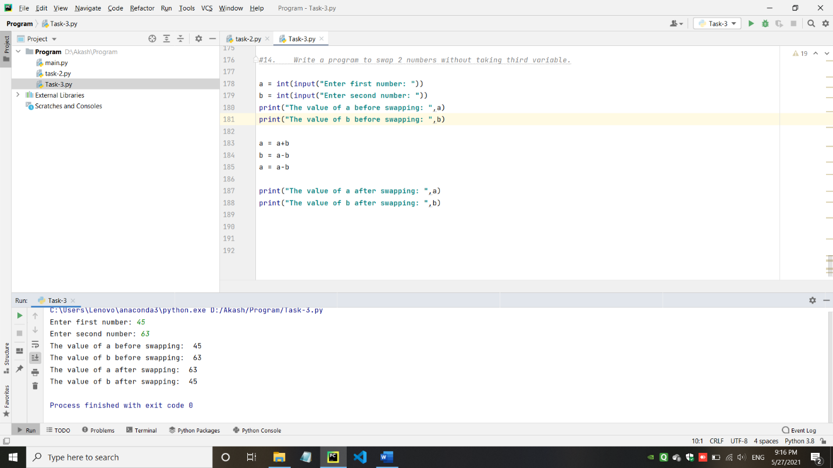

* Take starting number and ending number from the user and print following series.

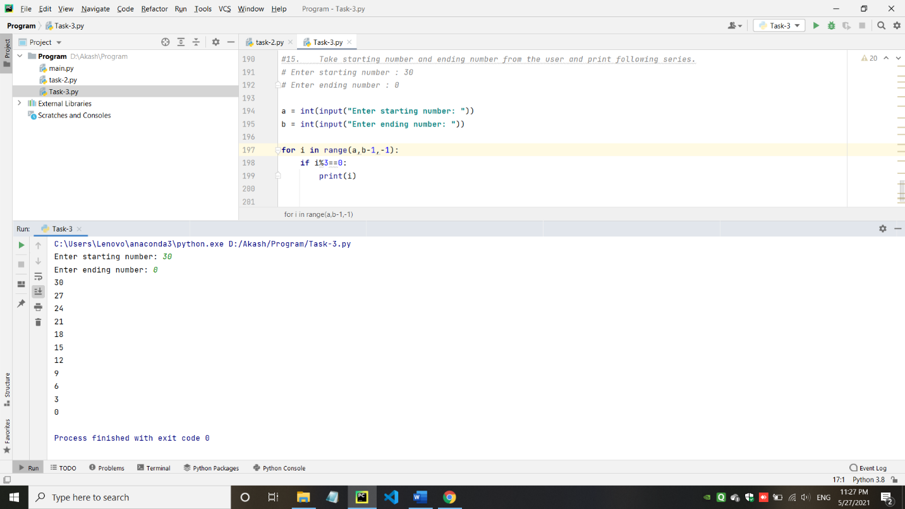

1. Task-4: Python OOP’s Concepts.

* Create a class cal3 that will calculate simple interest. Create constructor method which has three parameters .Create calInterest() method that will calculate Interest . Create display() method that will display Interest

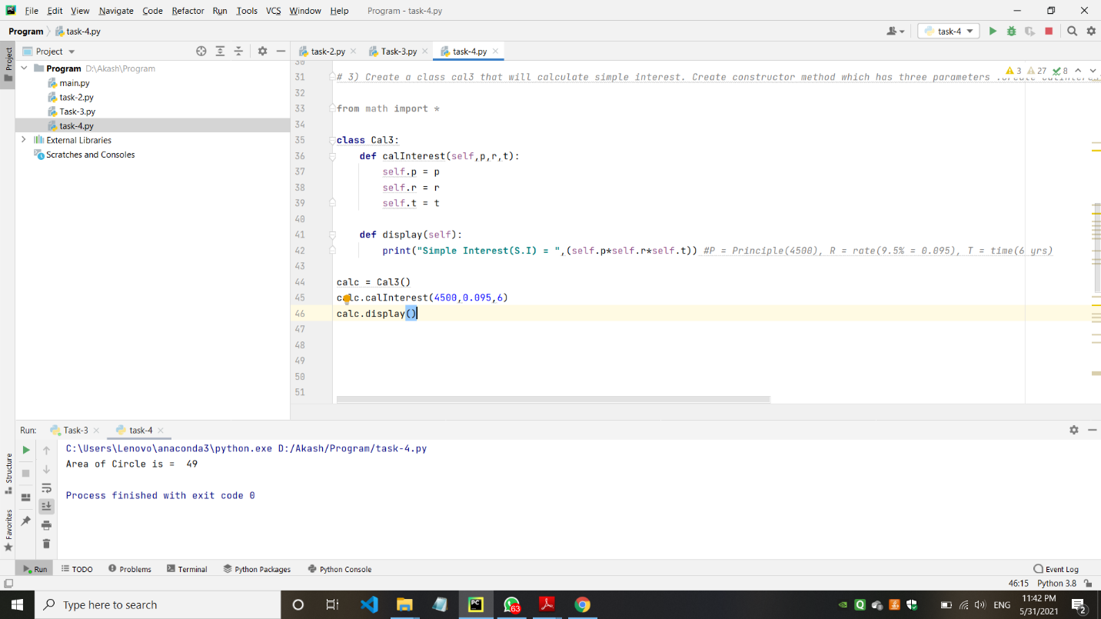

* Create a class cal5 that will calculate area of a rectangle. Create constructor method which has two parameters .Create calArea() method that will calculate area of a rectangle. Create display() method that will display area of a rectangle.

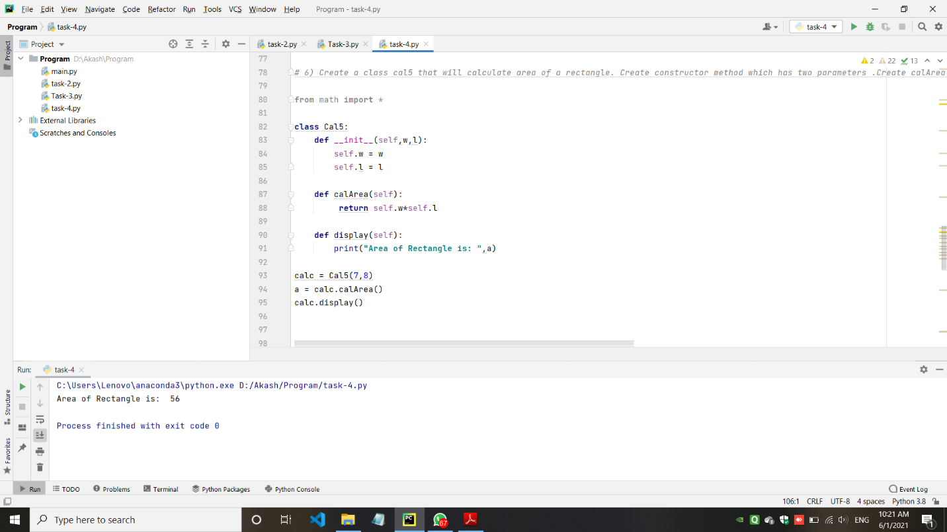

* Create an arith class. The class should have a parameterized constructor and methods to add, subtract and multiply two numbers and to return the answers.

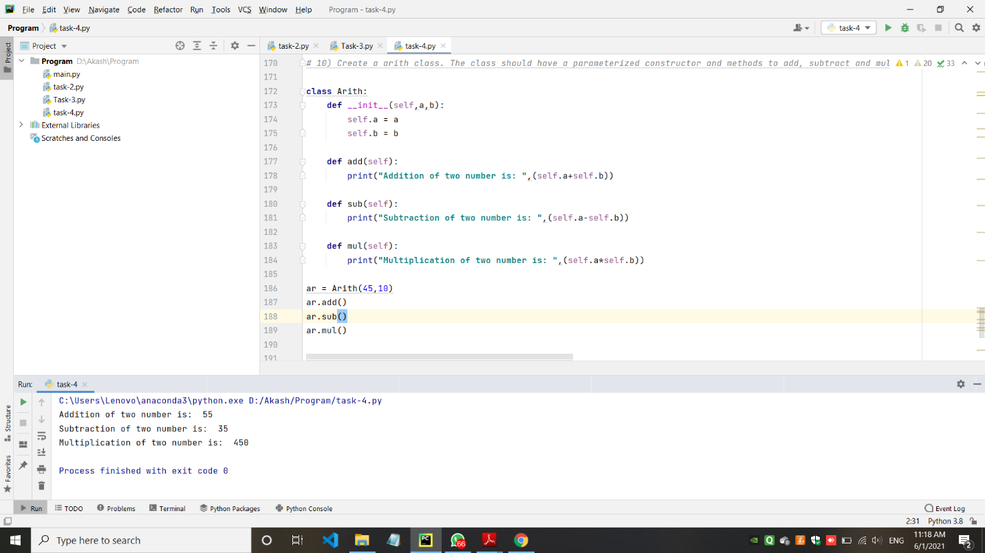

1. Task-5: Making simple pages using Django (Home, About, Contact).

* Views.py

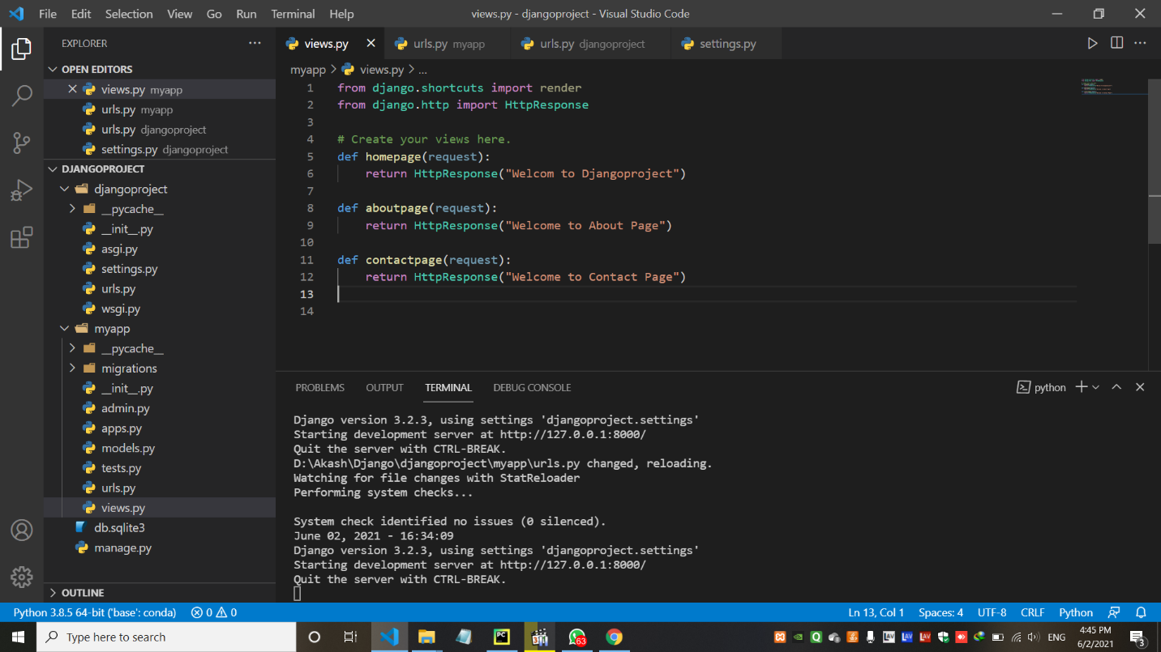

* urls.py (myapp)

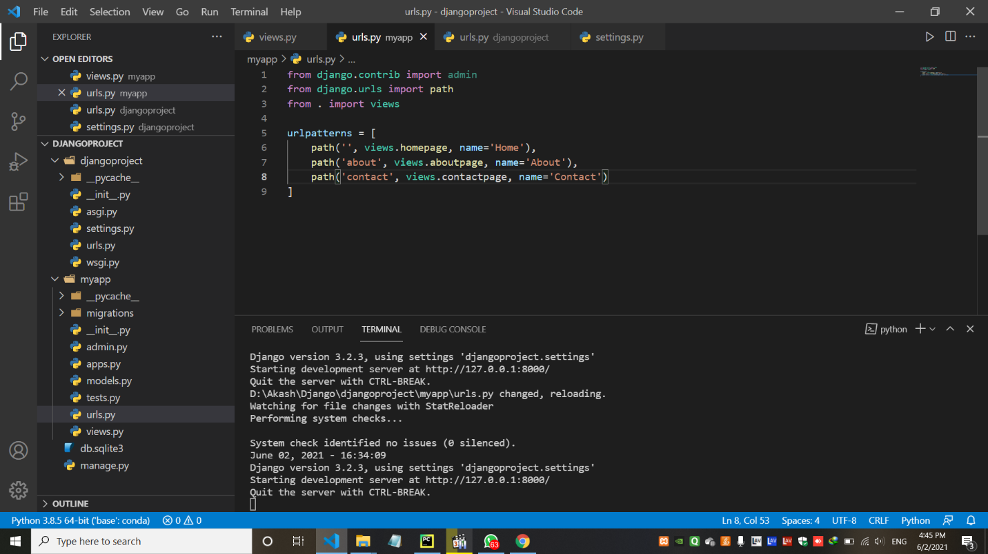

* urls.py (djangoproject)

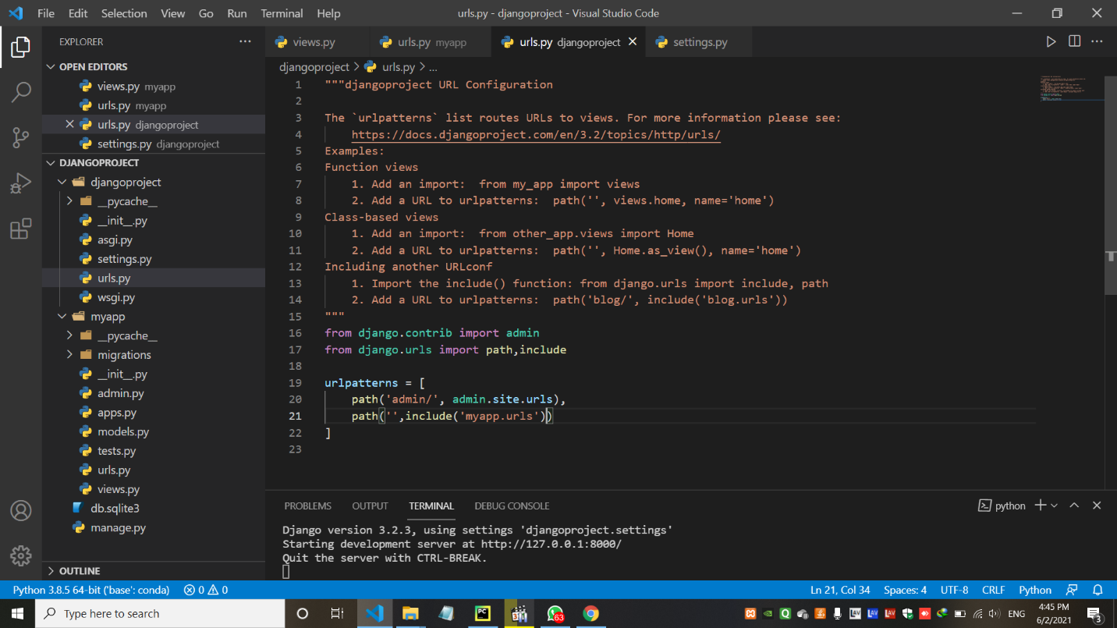

* settings.py

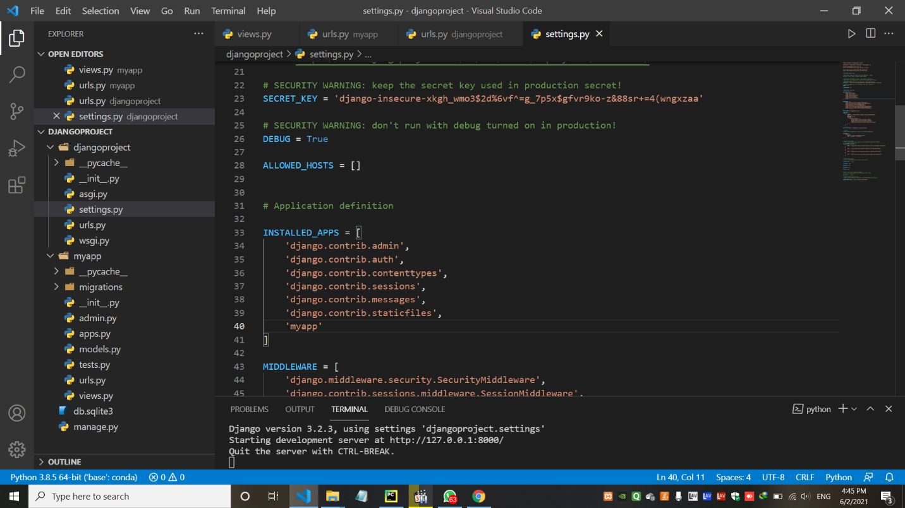

* Output – (Home Page with the text of Hello World)

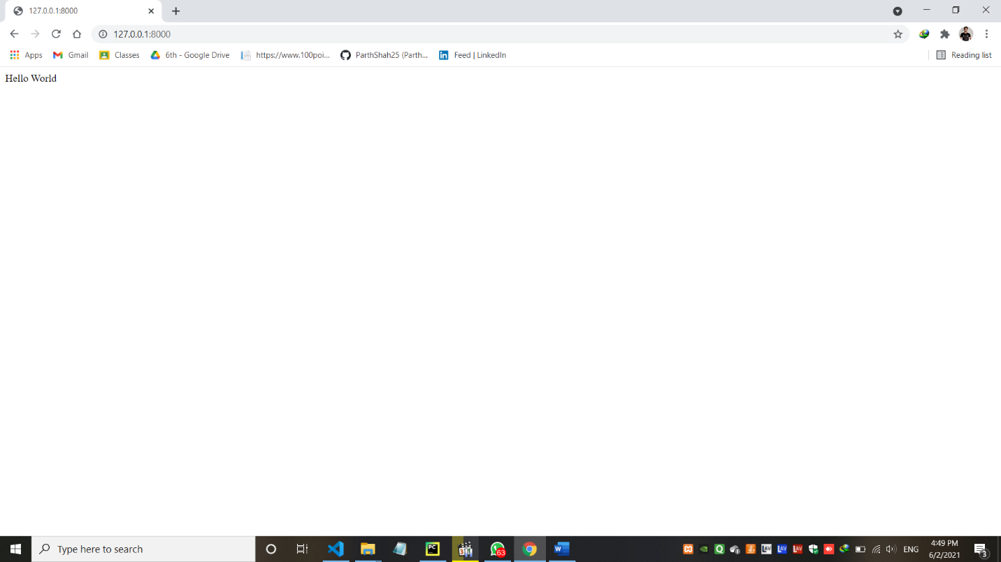

* Output – (About Page with the text of Welcome to About Page)

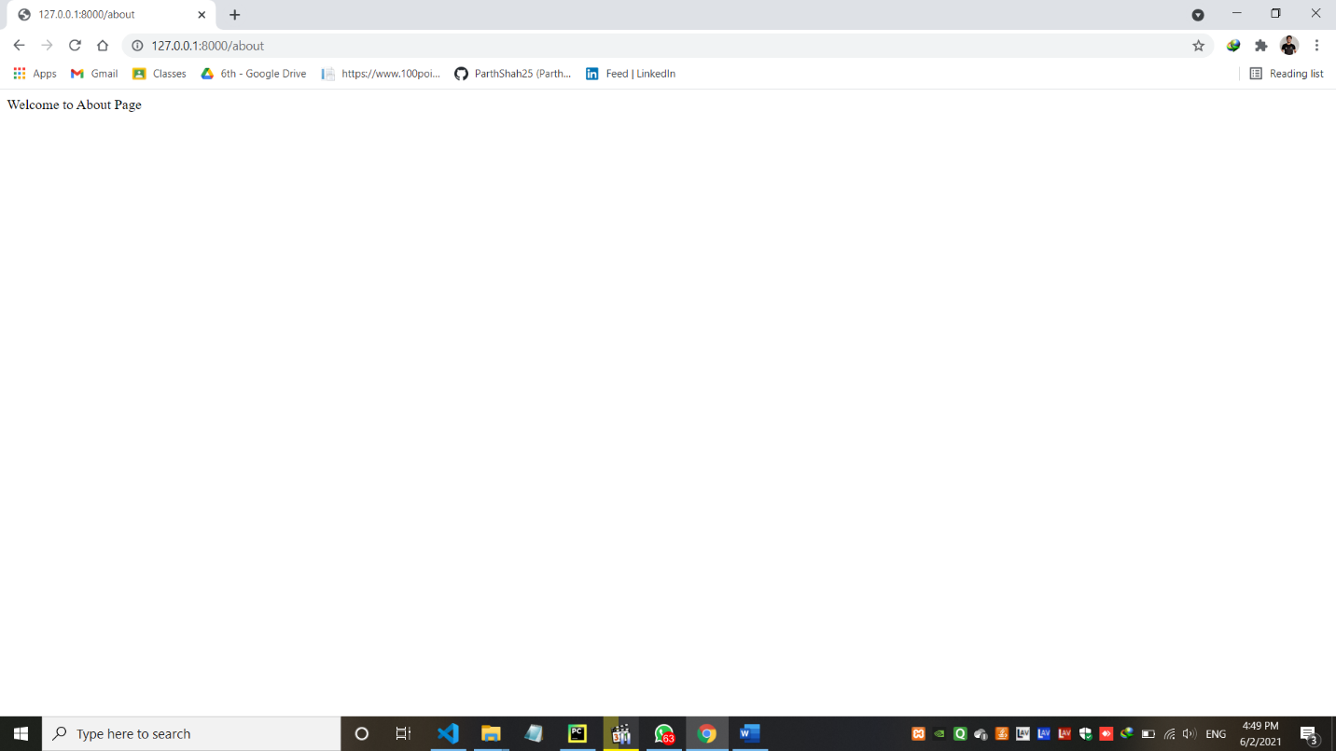

* Output – (Contact Page with the text of Welcome to Contact Page)

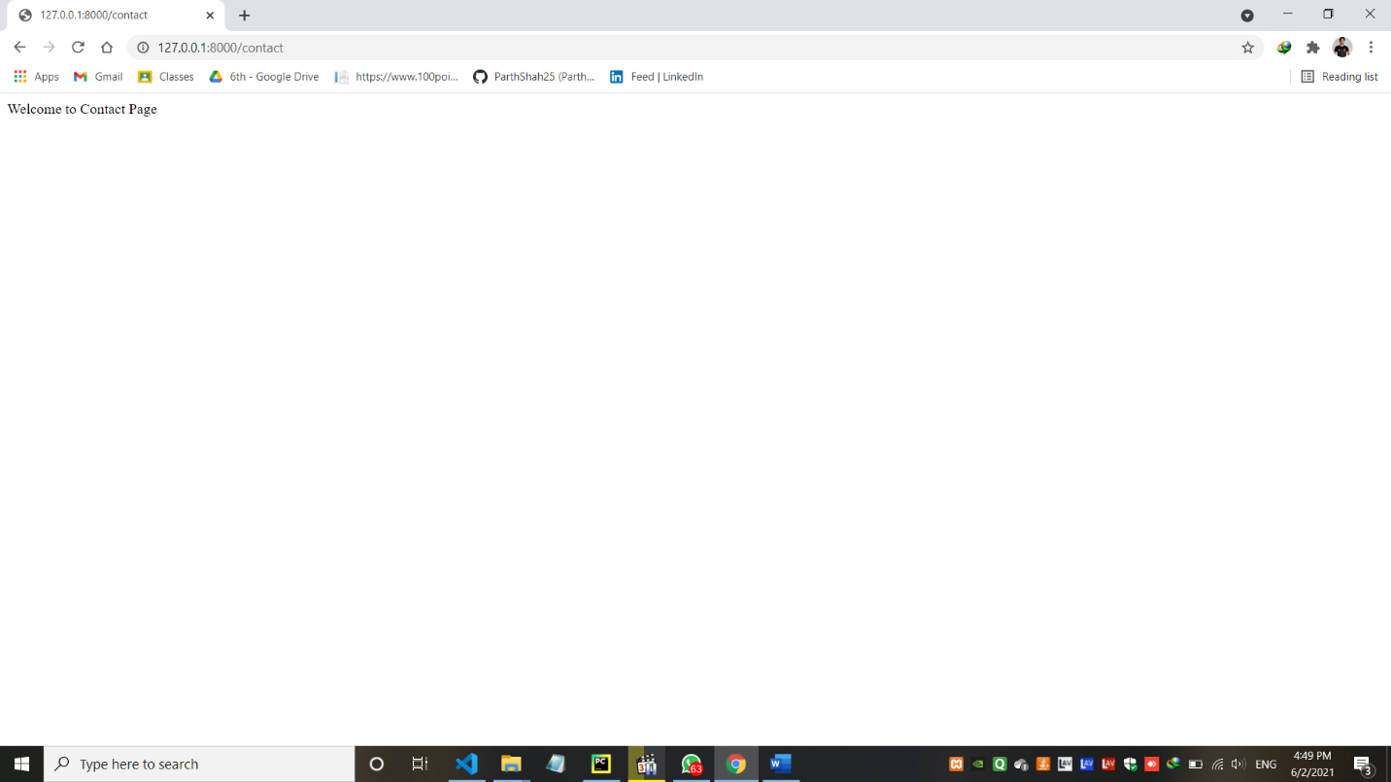

1. Task-6: Career Guidance website using Django.

* Project Pages: (urls.py)

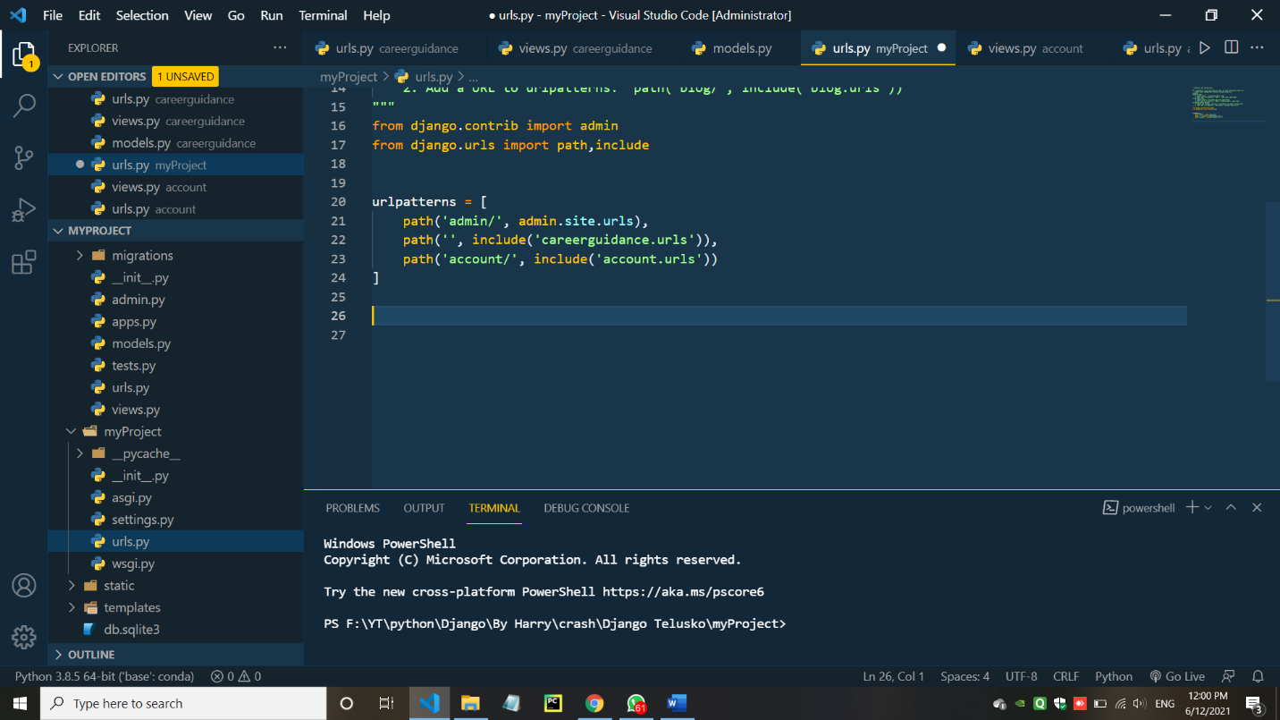

* Application Pages(Career Guidance and Account) :
* urls.py (Career Guidance)

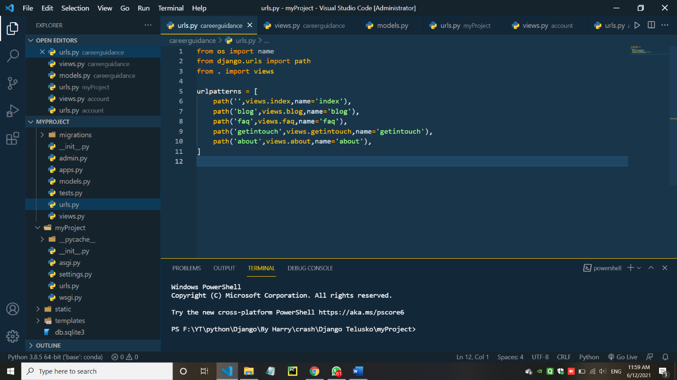

* views.py (Career Guidance)

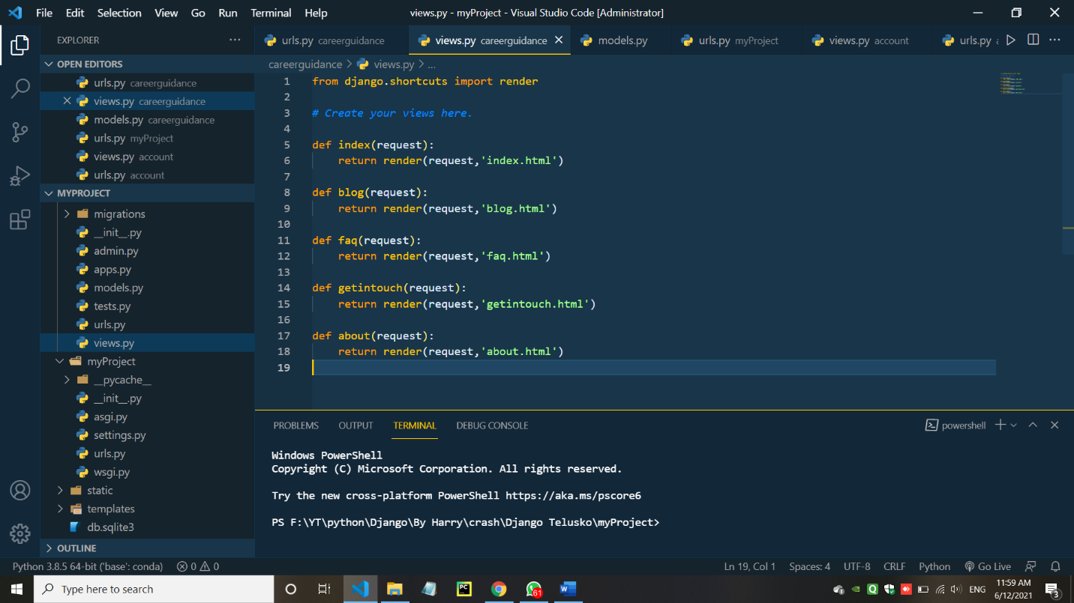

* models.py (Career Guidance)

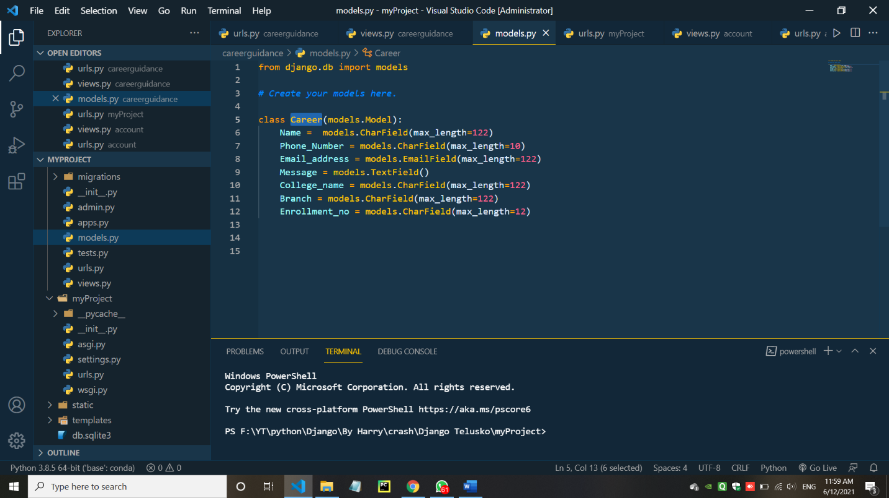

* urls.py (Account)



* views.py (Account)





* Output :

1. Home

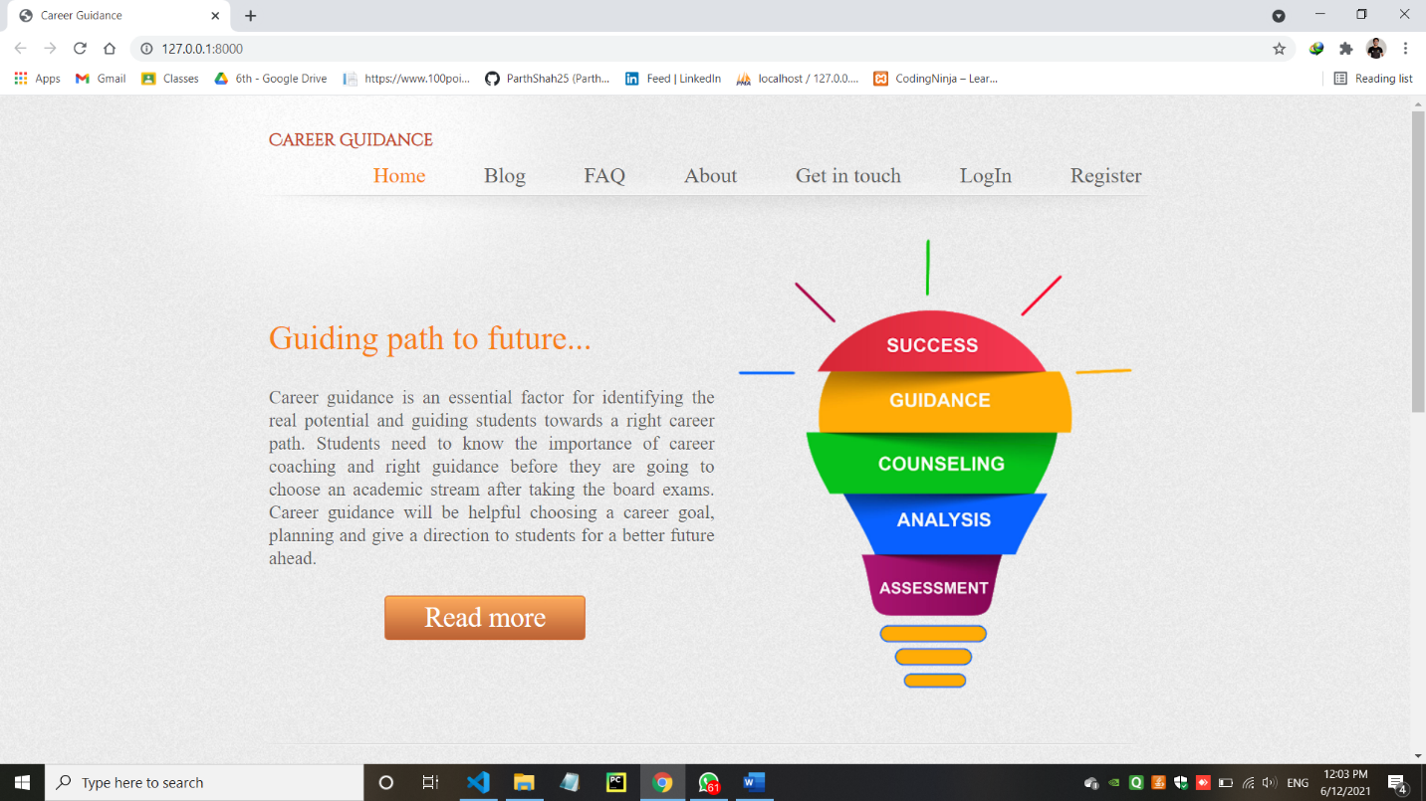

1. Blog

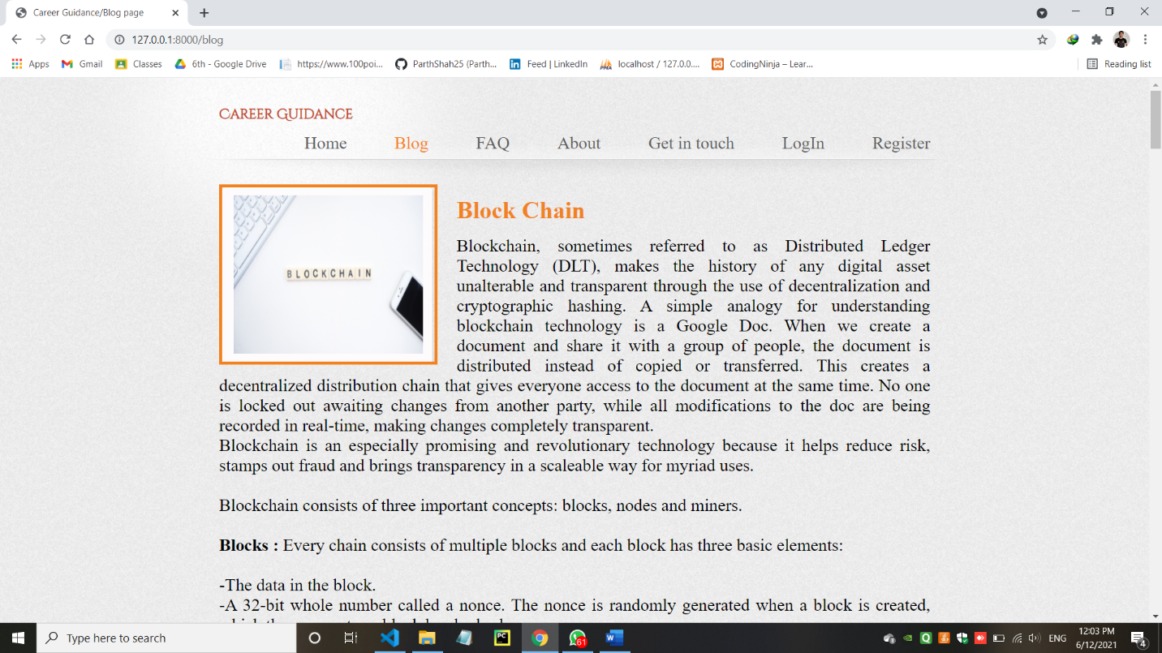

1. FAQ

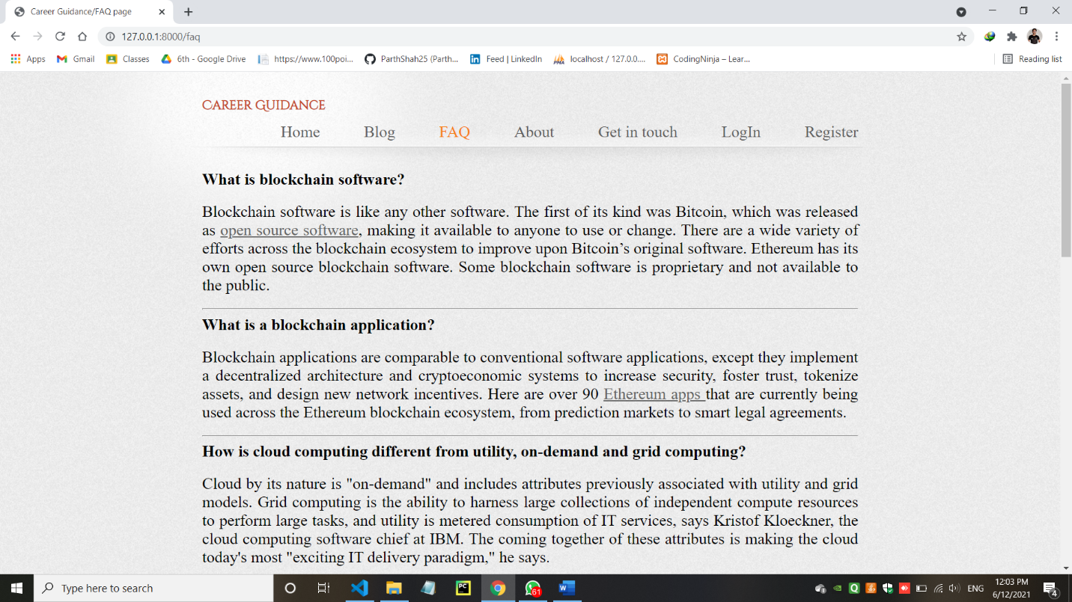

1. About

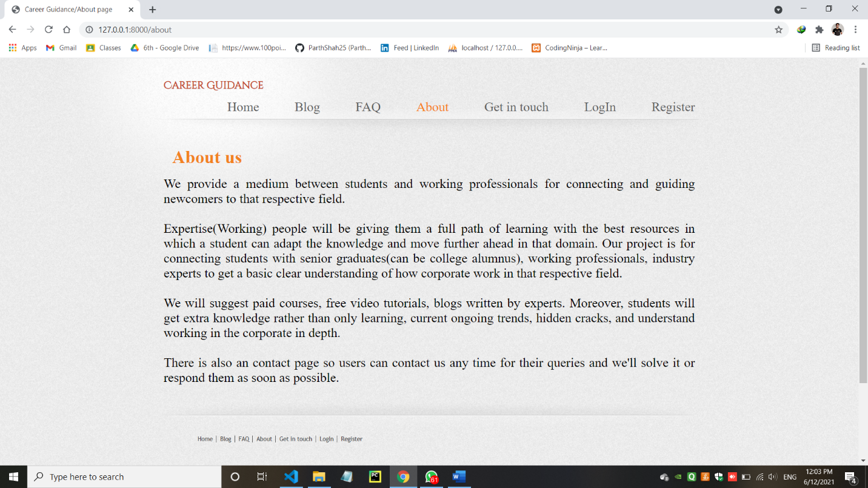

1. Get in Touch

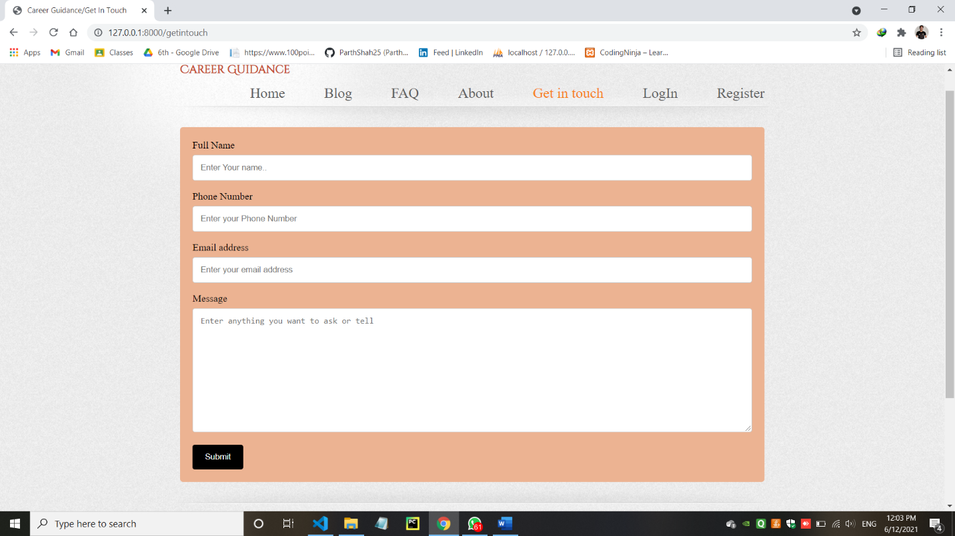

1. LogIn

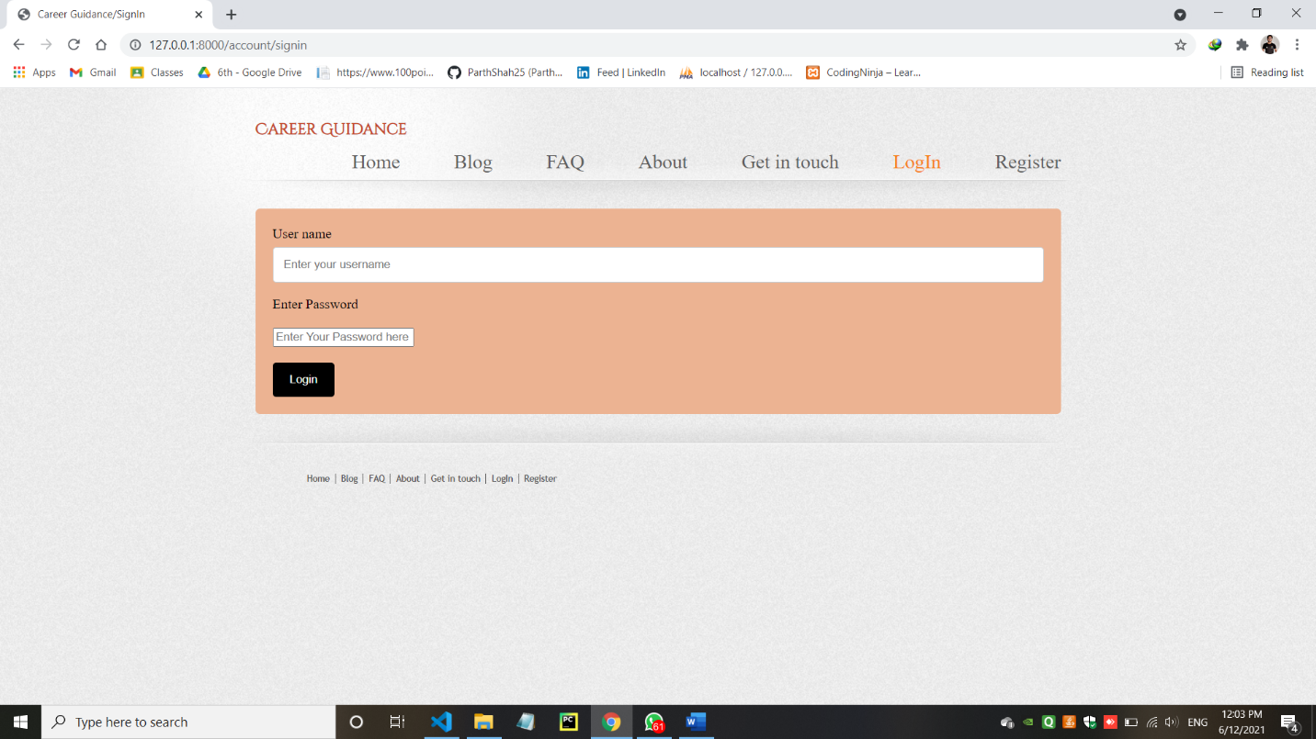

1. Register

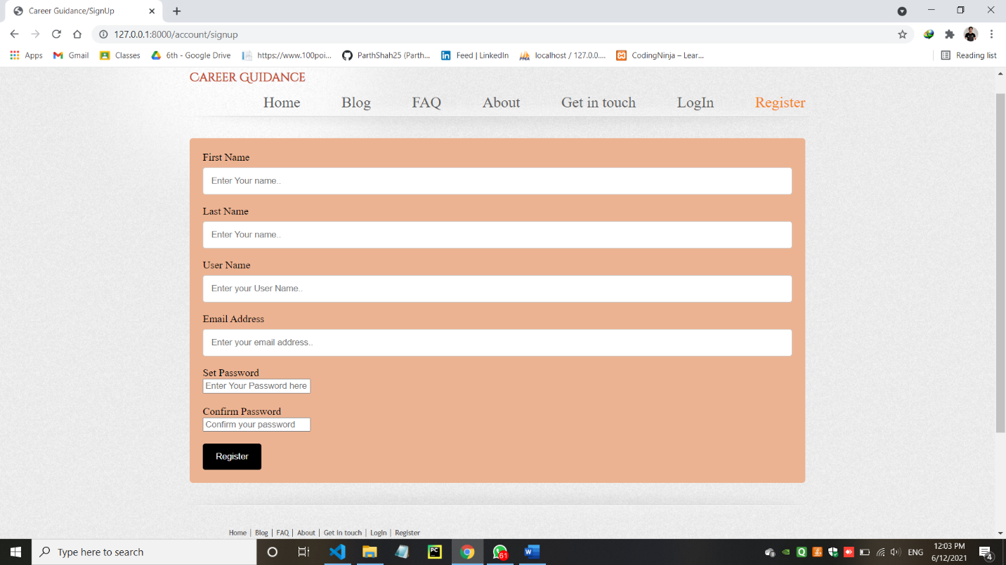

* pgAdmin Database auth-user data with the use of register page

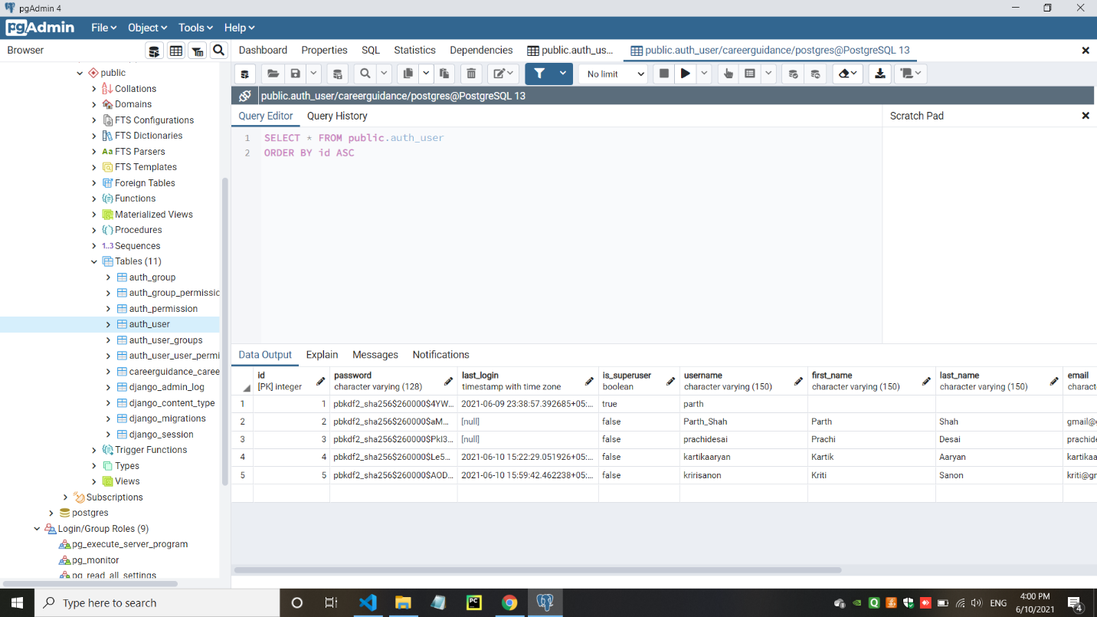

* Django/Admin panel data entry by the register page

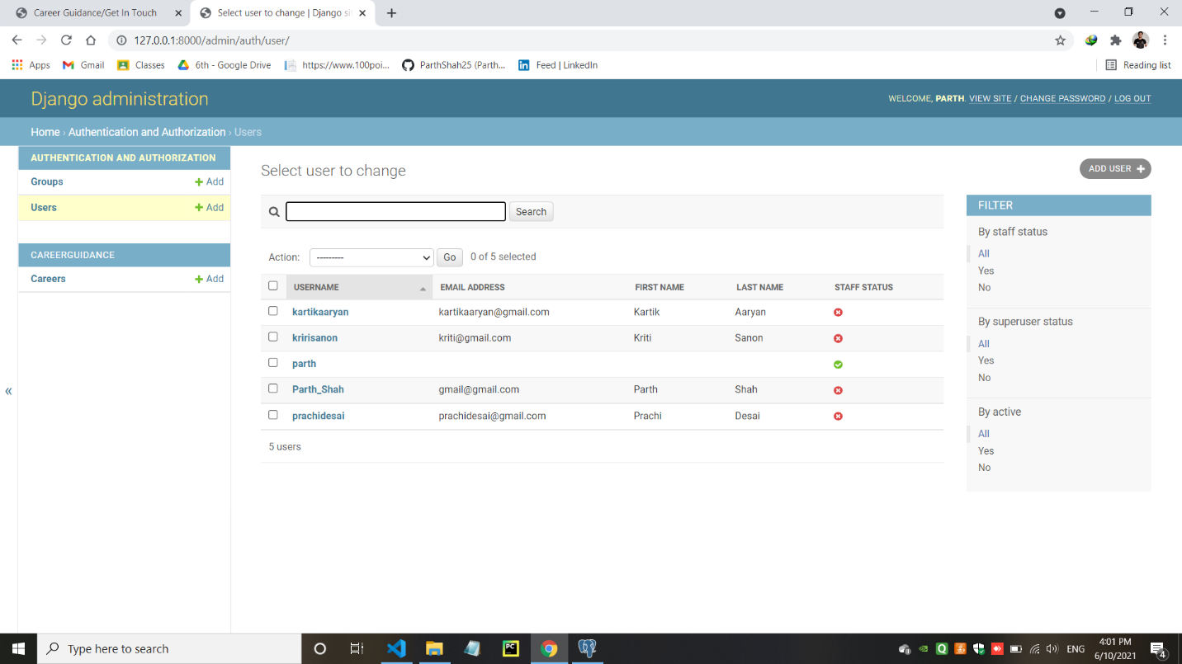

* CRUD operations using models.py page in the Django/Admin panel (Data Entry)

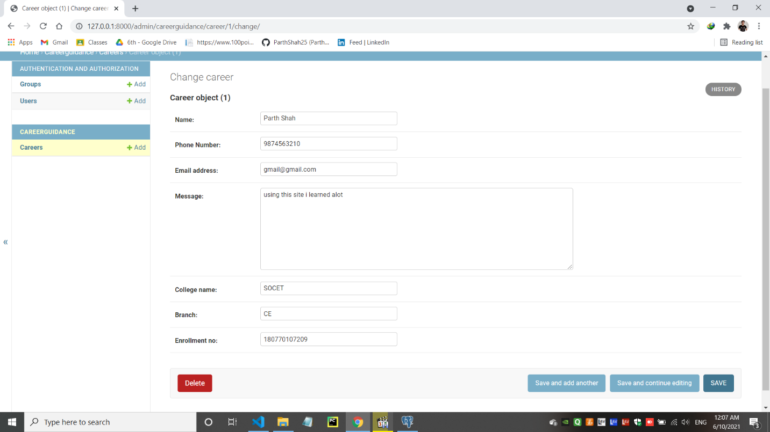

* CRUD operation’s Data store in the Django/Admin Panel.

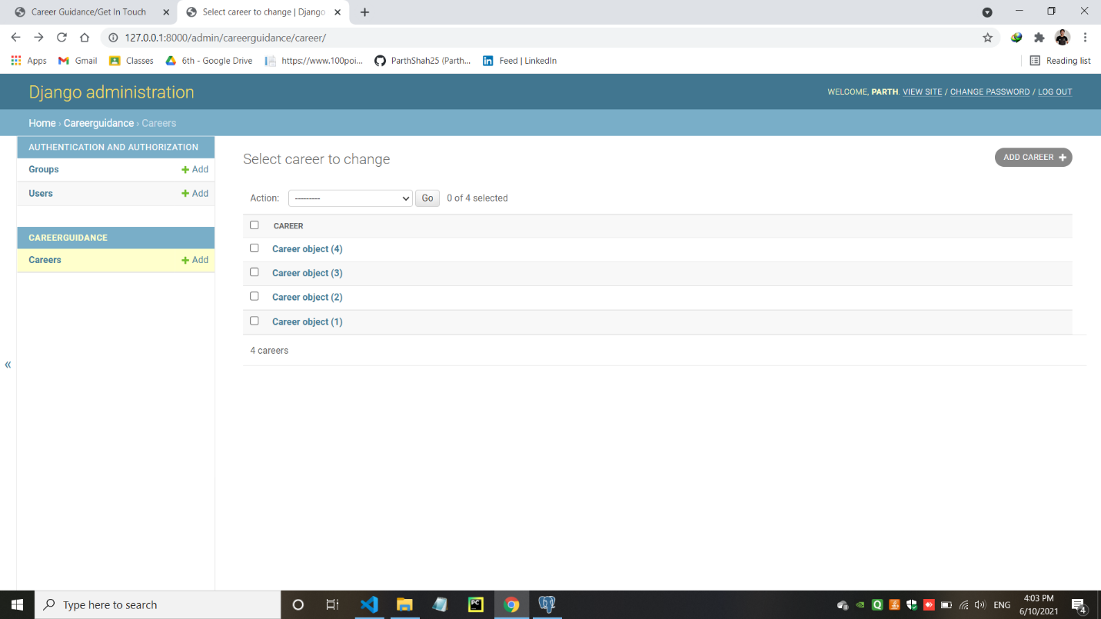

* When Data store in the Django/Admin panel they will also added in the pgAdmin Database

